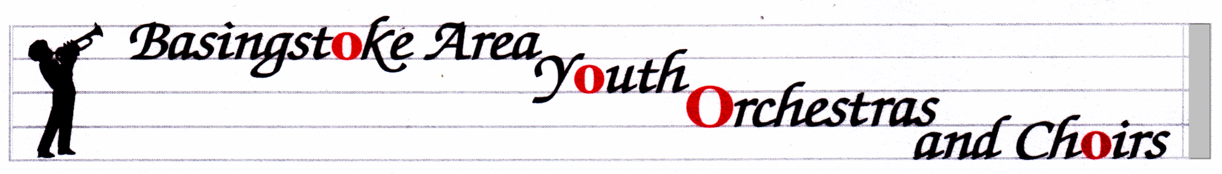
TADLEY AREA YOUTH WIND BAND
http://www.bayo-hampshire.org.uk/

05 November 2017
Dear Parents and musicians,

Our website above is a good way to make sure that you know what is going on with all the ensembles in the group, and with the Friends organization. My letters will always be on there in case you lose this emailed copy.

Concerts this year:
Sunday 10th December 2.30 at Queen Mary’s Hall in QMC. Park in the first car park that is on your left (the other car park is a longer walk) when you go onto the site and the hall is off the corner of this. Please arrive in plenty of time to set up, as we are on in the first half. I expect the concert to finish at about 4.30. This is also an opportunity to hear some of the other groups in BAYOC. We are, as ever, looking for raffle prize donations as well as donations of shop-bought mince pies/biscuits/mini cakes. If you would be willing to provide these, please bring them to a rehearsal in December. HELP WILL BE NEEDED – PLEASE SEE MY EMAIL FROM THE CHAIR OF FBAYOC, OR VISIT THE WEBSITE.

Saturday 24th February: At no cost to you whatsoever, we have a whole day planned, based at Great Binfields Primary School, designed to develop the players’ skills and experience, aiming for our performance at The Anvil in May. There will be a guest conductor in the afternoon, and a short performance at the end of the day. Please put it in your diary NOW and do your level best to be there. Only when we have everyone from the band there can we develop the overall sound of our ensemble. The day will run from 9.30 to 4.00 and I will get a letter out about it after Christmas.

SATURDAY 5th MAY 2018 – Anvil Concert 7pm, with rehearsal during the day (it is often 11.30-12.30 but that has not been organized fully yet). I’m afraid this is the Bank Holiday weekend but we can’t choose the dates, and at least we get the following 2 days off work/school.

Hire or Exchange Concert Uniform.

Members of our ensembles are required to wear a uniform for performances. If you are new and haven’t already done so, please go to the website for information on how to buy into the uniform system. If you haven’t tried your shirt on for some time, please do so…..now. The system we run means that the shirts can be exchanged for larger sizes at no extra cost. Go online, request the new size shirt, bring the old shirt in to me at a rehearsal, and the new shirt will soon appear like magic. Uniform is band shirt, plus tie for the boys, dark shirt/trousers and dark shoes.
NO rehearsals on Thursday 14th or 21st December. We restart rehearsals on Thursday 11th January 2018.
Mrs. Serena Ludford serena.ludford@hms.hants.gov.uk 07796 694049
12 Oakley Lane, Oakley, Basingstoke, RG23 7JZ

